Bio Inspired Systems (SEE Report) Grey Wolf Optimization

Name: Manojkumar
USN: 1BM23CS185
Subject: Bio Inspired Systems
Course Code: 23CS5BSBIS

Research Paper used : Distributed Systems Meet Cloud Computing: A Review of Convergence and Integration.

Link of the Paper : Research Paper Link

Application Used in Paper : Makespan reduction in VM task Allocation using Grey Wolf Optimization.

Abstract :
Conventional cloud computing, in which processing, storage, and networking resources are hosted in one or a few centralised data centres, has been made unsuitable as a result of the stringent latency requirements of emerging applications. Additionally, the rapid expansion of networks has led to the emergence of a trend known as network cloudification, which involves the delivery of network services based on cloud service models. Therefore, the development of the new distributed cloud model represents a progression from the conventional centralised cloud computing model to the worldwide distributed cloud computing services that are positioned according to the needs of the application. In this essay, we make an effort to provide a comprehensive overview of clouds that are dispersed. The first thing that is discussed is the concept of distributed cloud computing. We will now continue to outline the architecture of the distributed cloud as well as the technologies that are linked with it. We also carry out a case study as part of our work. When it comes down to it, we tackle open research problems that are associated with distributed cloud computing. by conducting a comprehensive review of twenty-one papers that cover a wide range of methodology and approaches.

Comparsion and Results :

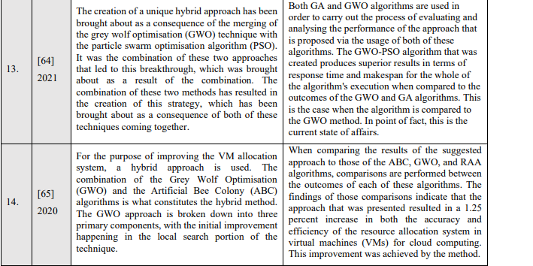

Code for Application :

import numpy as np
import random

num_tasks = 20
num_vms = 5

task_length = np.random.randint(1000, 10000, num_tasks) # MI
vm_mips = np.array([500, 1000, 1500, 2000, 2500]) # MIPS

def fitness(solution):
vm_time = np.zeros(num_vms)
for task_id, vm_id in enumerate(solution):
vm_time[vm_id] += task_length[task_id] / vm_mips[vm_id]
return max(vm_time)

wolves = 30
iterations = 100

# Initialize wolves (task → VM mapping)
population = np.random.randint(0, num_vms, (wolves, num_tasks))

alpha, beta, delta = None, None, None

for t in range(iterations):
fitness_values = np.array([fitness(wolf) for wolf in population])
sorted_idx = np.argsort(fitness_values)

alpha = population[sorted_idx[0]]
beta = population[sorted_idx[1]]
delta = population[sorted_idx[2]]

a = 2 - t * (2 / iterations)

for i in range(wolves):
for j in range(num_tasks):
r1, r2 = random.random(), random.random()
A1 = 2 * a * r1 - a
C1 = 2 * r2

D_alpha = abs(C1 * alpha[j] - population[i][j])
X1 = alpha[j] - A1 * D_alpha

r1, r2 = random.random(), random.random()
A2 = 2 * a * r1 - a
C2 = 2 * r2

D_beta = abs(C2 * beta[j] - population[i][j])
X2 = beta[j] - A2 * D_beta

r1, r2 = random.random(), random.random()
A3 = 2 * a * r1 - a
C3 = 2 * r2

D_delta = abs(C3 * delta[j] - population[i][j])
X3 = delta[j] - A3 * D_delta

new_position = int(round((X1 + X2 + X3) / 3))
population[i][j] = np.clip(new_position, 0, num_vms - 1)

if t % 10 == 0:
print(f"Iteration {t}, Best Makespan = {fitness(alpha):.4f}")

print("\nBest Task-VM Mapping:")
print(alpha)
print("Final Makespan:", fitness(alpha))

Output :

